14) Configuration of Distance Routing protocol using packet tracer
Introduction:-
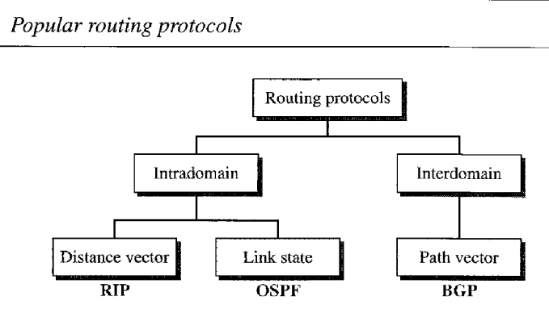
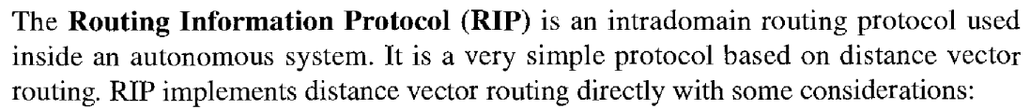
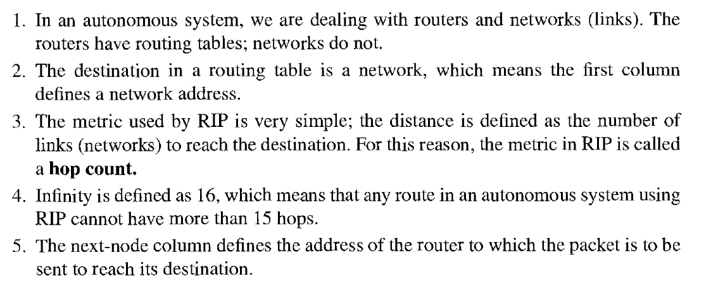

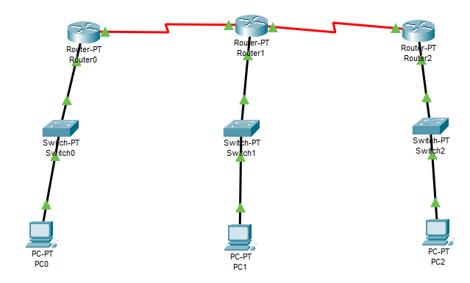

Configuration:-
Router 0:-
- At Router0 Configuration:
- FastEthernet 0/0
- Port status: on
- IPV4 address: 192.168.10.1
- subnetmask:255.255.255.0
Seial 2/0
- portstatus:on
- clock rate:64000
- IPV4 address:192.168.12.1
- subnetmask:255.255.255.0

RIP
- 192.168.10.0
- Add Network
- 192.168.11.0
- 192.168.12.

At Router 1 Configuration:-
- Faster Ehternet:0/0
- portstatus:on
- IPV4:192.168.11.1
Subetmask:255.255.255.0
Serial2/0
- portsatus:0n
- clock rate:64000
- IPv4:192.168.12.2
- Subnetmask:255.255.255.0

RIP
- 192.168.10.0 ADD Network
- 192.168.10.0
- 192.168.11.0
- 192.168.12.0

PCO;-
- IPV4: 192.168.10.2
- Subnet:255.255.255.0
- Default Gateway:19.168.10.1

PC1:
IPV4:192.168.11.2
Subnet:255.255.255.0
Default Gateway:192.168.11.1

Output:-

